**Assignment 24.5**

**Create database and use it**

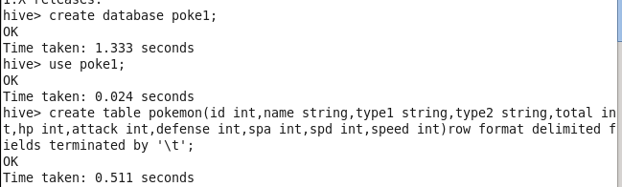

**Describe table**

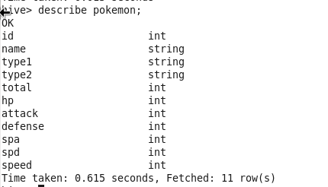

**Load the data**

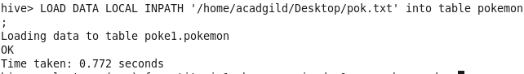

**Dataset**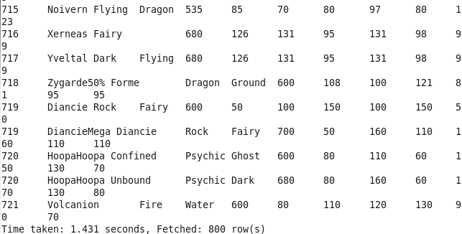

1. **Find out the average HP (Hit points) of all the Pokémons**

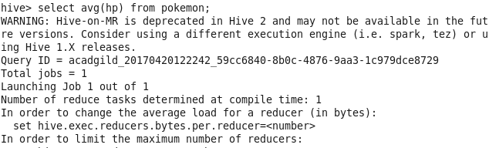

**OUTPUT**

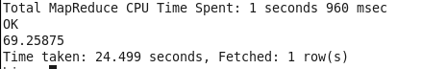

**2. Find out the average Defense of all the pokemon**

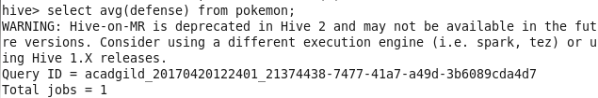

**OUTPUT**

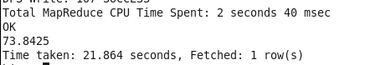

**3.Find out the average Sp.Atk of all the pokemons**

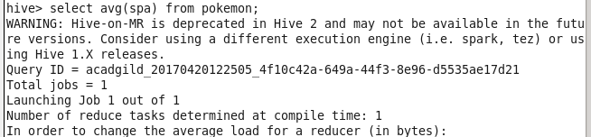

**OUTPUT**

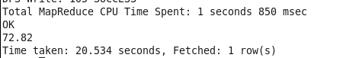

**Q4) Find out the average sp.Def of all the pokemons**

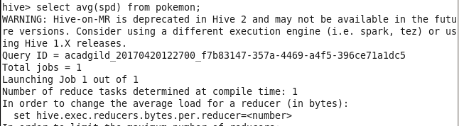

**OUTPUT**

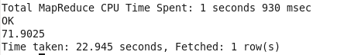

**5. Find out the average Speed of all the pokemons**

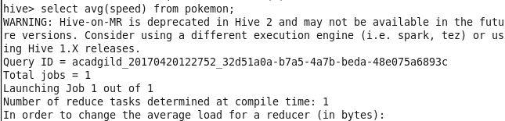

**OUTPUT**

